ANNEX

Arbitration

The Parties agree that any dispute or disagreement relating to this contract or resulting from its interpretation or application will be settled definitively by arbitration and excluding the ordinary courts, according to the laws of Quebec. The arbitration will take place in Montreal under the aegis of a single arbitrator and will be conducted in accordance with the rules of law and the provisions of the Code of Civil Procedure of Quebec in force at the time of this dispute or disagreement. The Parties entrust Arbitration Montréal Inc., subject to its acceptance, with the appointment of this arbitrator from amongst the members of its personnel. During this arbitration, the Parties will represent themselves, and will give the arbitrator as much leeway as possible in the conduct of the trial and the choice of the procedure to be applied. The Parties and the arbitrator shall maintain the confidentiality of the entire process and of the decision rendered. The losing Party, as the case may be, shall assume all the fees and disbursements of the arbitrator and the compensation of any witnesses and experts. The arbitration award shall be binding on the parties and shall be final, enforceable and without appeal.

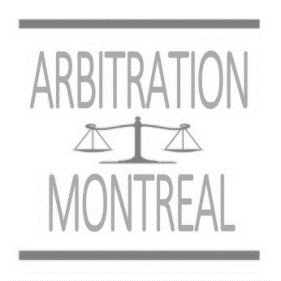

www.ArbitrageMontreal.com
438-807-6355
info@arbitragemontreal.com

SIGNATURES OF THE PARTIES :

_________________________ _________________________

_________________________ _________________________

_________________________ _________________________

